|  |  |
| --- | --- |
| C:\Users\logon\Desktop\download.jfif | DEPARTMENT OF INFORMATION TECHNOLOGY |

|  |  |
| --- | --- |
| Subject: Wireless and mobile Network (WMN) | Subject Code: 22622 |
| Semester: 6th | Course: IF6IA |
| Laboratory No: | Name of Subject Teacher: Kalyani Pawar |
| Name of Student: Yash Rajendra Hajare | Roll Id: 18202A0024 |

|  |  |
| --- | --- |
| Experiment No: | 9 |
| Title of Experiment | Simulate the Binary Phase shift keying using MATLAB and Simulink. |

* **Aim:**

Simulate the Binary Phase shift keying using MATLAB and Simulink.

* **Practical Significance:**

PSK technique is widely used for wireless LANs, biometric, contactless operations, along with RFID and Bluetooth communications. BPSK has a bandwidth which is lower than that of BFSK signal. It has a very good noise immunity. This practical enable the students to generate and decode BPSK signal.

* **Minimum Theoretical Background**



**Figure 1: Generation of PSK/BPSK Modulator**



**Figure 2: Waveform of BPSK Modulation**



**Figure 3: BPSK demodulator**



**Figure 4: Practical set up for BPSK modulation and demodulation**

 

1. (b) (c)

**Figure 5: Waveforms of (a) Carrier signal (b) Modulating signal (c) PSK output**

* **Procedure:**

**For practical set up Circuit Diagram**

a. Make connections as shown in figure.

b. Select input data 11001011 from data generator using switches and connect it to bipolar convertor.

c. Connect bipolar data to signal input of balanced modulator (BPSK modulator)

d. Select carrier signal from carrier generator and connect it to carrier input of balanced modulator (BPSK modulator).

e. Switch on the power supply.

f. Connect DSO/CRO probe at output of balanced modulator (BPSK modulator).

g. Observe output waveforms of balanced modulator (BPSK modulator) on CRO.

h. Write output signal phase shift with respect to carrier for input signal (logic 1 and logic 0) in observation table.

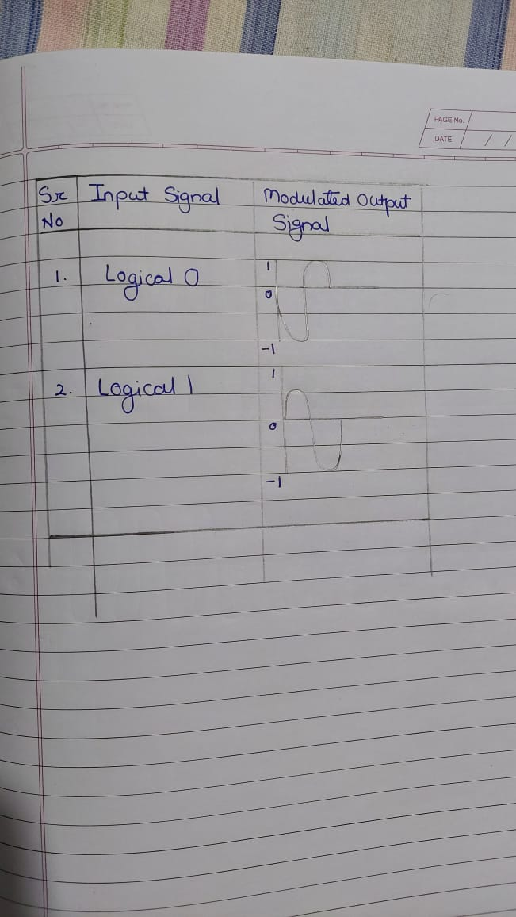

i. For BPSK demodulation connect output of balanced modulator (BPSK modulator) to input of BPSK demodulator kit as shown in figure.

j. Observe the output of low pass filter on CRO/DSO.

k. Draw the waveform of input data, carrier signal, BPSK signal and output of low pass filter on graph paper for observed value.

l. After completion of practical switch off the supply, remove the connection and submit the wires and equipments.

**For Simulation**

a. Switch on the computer and click on the MATLAB icon.

b. Go to start at the bottom of the command window, then select “simulink” then go to library browser and drag it into creating file.(or) Once you open the MATLAB then click on simulink icon .Go to file and select new and then select model. You will get a new window.

c. Arrange the functional blocks as shown in simulink model.

d. Assign required parameters to each functional block.

e. Observe the outputs on scope.

* **Simulink Model of Binary Phase Shift Keying Technique**



* **Simulation Output**



## **Practical related Questions**

1. Draw BPSK modulated waveforms for input data 11110000

Ans-

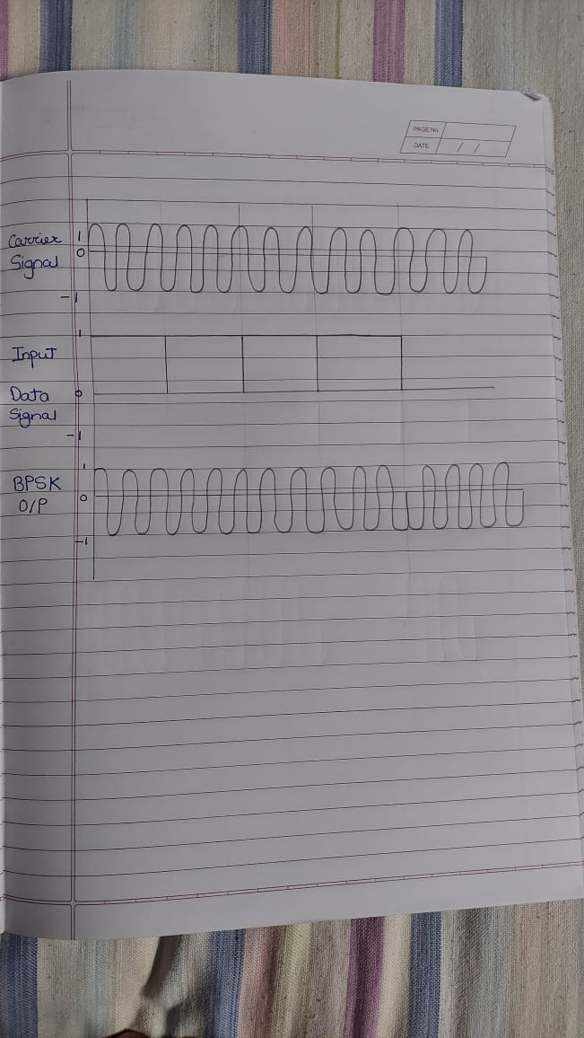

1. Draw BPSK modulated waveforms for input data 10101010

Ans-

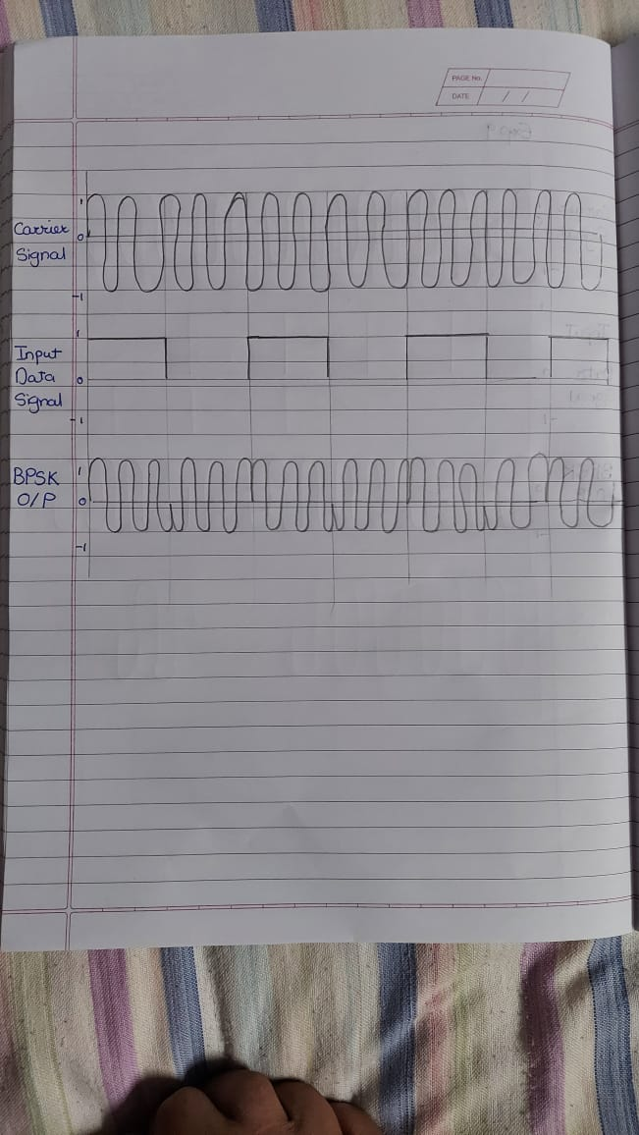

1. Draw BPSK modulated waveforms for input data 11111111

Ans-



1. Draw BPSK modulated waveforms for input data 11001100

Ans-

|  |  |  |  |  |  |
| --- | --- | --- | --- | --- | --- |
| **Grade and Dated Signature of Teacher** | **C (4M)** | **P (4M)** | **A (2M)** | **Total ( 10 M)** | **Dated Sign** |
|  |  |  |  |  |

